REPORT MA04 – Helen Hovdastad

INTRO

*“It is important to get a good understanding of social and development design disciplines in graphic design history. To illustrate this, you are to create a website with an interactive timeline or list. It will tell the graphic design history story from 1950 to today. The website must adapt to all screen types and the selected period must be easy to recognize. It should also navigate to more information regarding each period with 2-3 well known graphic designers of that time. It should also parallel social events perhaps affecting that chosen time.”*

The following styles / periods must be included:

* Pop Art (ca.1950-1970)
* International Typographic Style / Swiss style (ca.1950- late 1960)
* Psychedelic Movement (ca.1960 two mid 1970)
* Graffiti and Street art (ca.1980-)
* New Wave / Punk (ca.1970 two mid 1980)

RESEARCH AND PLANNING

I started with researching which artist I wanted to use on my website in each style. I found some popular artists and saw which art I personally liked the most. I ended up with Andy Warhol and Roy Lichtenstein for Pop art, Armin Hofman and Ernst Keller for swiss style, Wes Wilson and Victor Moscuso for psychedelic movement, Cornbread and Daze for street art and Jamie Reid and April Greiman for punk/new wave.

I wanted a simple, clean site which is easy to use. My thoughts for the “home” site were one about button which explains about graphic design history, instead of having it pasted right on the main site. Then I just wanted one link each design style/period. Each period is a page parted in two with information and pictures from each artist.

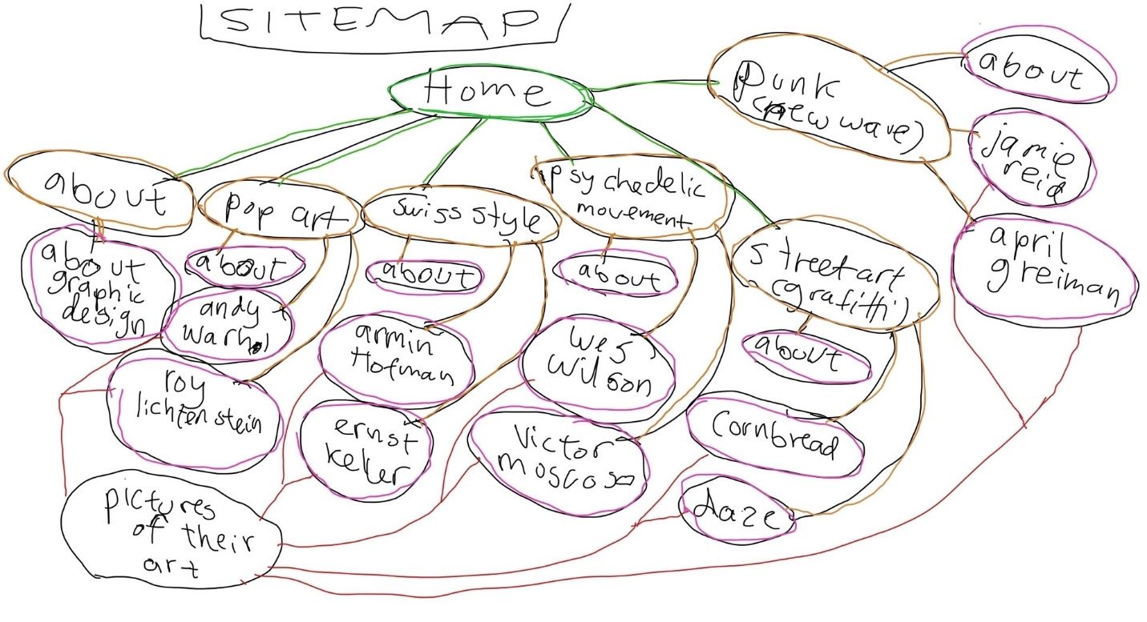

SKETCHING/DESIGN

I drew some sketches according to what I was thinking. As I said above, I didn’t want to write the about-text on the home-site, but I drew one sketch like that anyway just to see, and that verified what I thought. So, the design I chose was between number two and three. I actually mixed them together. The upper part of number two looked cleaner but on number three the link-setup looked better and cleaner with six options instead of five.

